Cumulative Incidence Reports (URI, Diarrhea and More)

Contents
Overview 2
Purpose and Scope 2
Definitions 2
Purpose 2
Rationale 2
Scope 2
Operational Areas Encompassed 3
Methodology 3
Stratification 3
Timeframe 3
Numerator and Denominator 4
Filters 4
Data Visualization 5
Quality Control 11
Technical Implementation 11
Source Data Updates 11
Current Code Repository 11
Report Generation Logic 11
Data Outputs 12
Excel-based Reporting File 12
Online Summary Dashboard 12
Automation and Operations 13
Scheduled Execution 13
Report Change Log 13

Overview

Purpose and Scope

Definitions
The cumulative incidence is the proportion of a population that develops a condition over a specified time period.

Purpose
The incidence of shelter-acquired illness is a key measure of medical preventive care and animal husbandry. Two key disease complexes were selected for the main reports.

Rationale
Shelters are high-risk environments and some shelter-acquired morbidity is inevitable. This is particularly the case as regards infectious diseases and those impacted by stress. However, uncontrolled high morbidity is unacceptable and requires remediation. Sudden spikes are indications of a new problem that must be addressed. A second purpose of the report is to create baselines for incidence against which current incidence can be assessed.

Scope
Shelter-acquired disease. A wait period is built in to exclude animals that came into the shelter with the disease or were suspected to have been ill or incubating at intake (accounted for by built-in time lags).

The main reports are:
- Cumulative incidence (CI) of upper respiratory infection (URI) in cats and canine infectious respiratory disease complex (CIRDC) in dogs. Referred to as URI for both species here
- Cumulative incidence of diarrhea in dogs and cats

Additional monthly CI reports are:
- CI of parvoviral enteritis
- CI of panleukopenia
- CI of dermatophytosis (ringworm)

The report is easily adjusted for any other condition that is routinely tracked by the shelter, and these alternative reports can be run by changing the condition(s) specified in the code and, if needed, tweaking parameters such as species, age group or time to onset.

Operational Areas Encompassed
- Vaccination
- Infection control
- Risk identification and response
- Risk at source
- Capacity for care
- Stress reduction
- Diet

Methodology

Stratification
Age groups – juveniles (0-20 weeks) and adults (> 20 weeks)
Species – dogs and cats

Timeframe
Monthly CI is calculated. The report includes 6 years of information to allow analysis of trends over time.

Numerator and Denominator
Calculation of Cumulative Incidence [Adapted from Every Nose Counts]
Number of cats with Condition entered in month of interest | A | Numerator
Total intake in the month of interest | B | Denominator
Total animals already in the shelter | C | Denominator
Animals that entered the shelter with Condition | D | Exclude
Second intake of the same animal in the same month | E | Exclude
CI = new cases / population at risk
New cases = cases included = A
Population at risk PR = included – excluded = (B+C) – (D+E)
CI = New cases/population at risk %

Filters
Filter | Report | Details
Species |  | Cat, Dog
Intake Type |  | Owner surrender, Transfer in, Stray, Return
Beginning of month |  | 12:00:00 AM, first day of month
Conditions | Diarrhea | Diarrhea  Diarrhea, acute, nonspecific  Diarrhea and vomiting, acute, nonspecific
 | URI/CIRDC | Kennel cough  URI, feline
 | Parvovirus | Parvovirus, canine  Parvovirus, feline, suspected  Parvovirus, feline, confirmed
 | Ringworm | Ringworm, confirmed
Days excluded after admission (for shelter-acquired) | Diarrhea | > 1 day
 | URI | > 3 day
 | Parvovirus | > 3 days*
 | Ringworm | > 7 days*

Data Visualization

This section provides selected screenshots of reports as they currently appear.

Cumulative Incidence of Canine Diarrhea. Incidence (line graph, right axis) is superimposed on population at risk, stratified by age group (stacked bars, left axis).
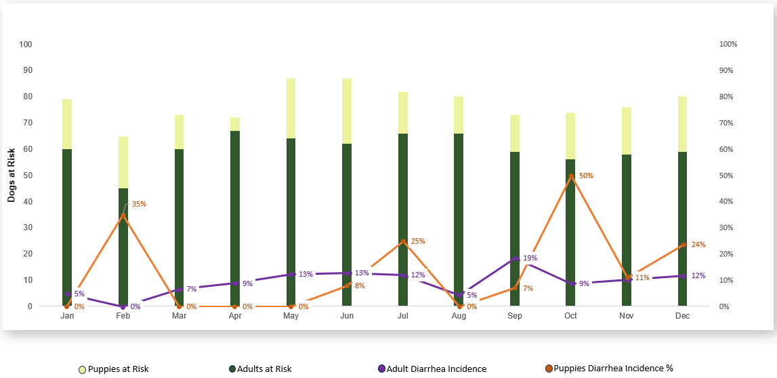

Cumulative Incidence of Feline Diarrhea. Incidence (line graph, right axis) is superimposed on population at risk, stratified by age group (stacked bars, left axis).

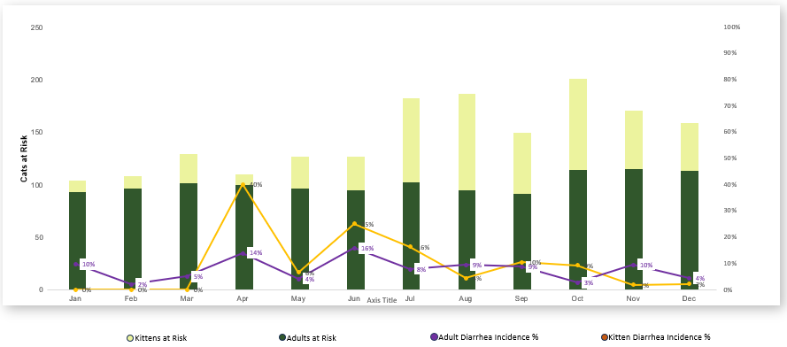

Cumulative Incidence of Feline URI. Incidence (line graph, right axis) is superimposed on population at risk, stratified by age group (stacked bars, left axis).

The summary data at the top shows overall incidence for the year.

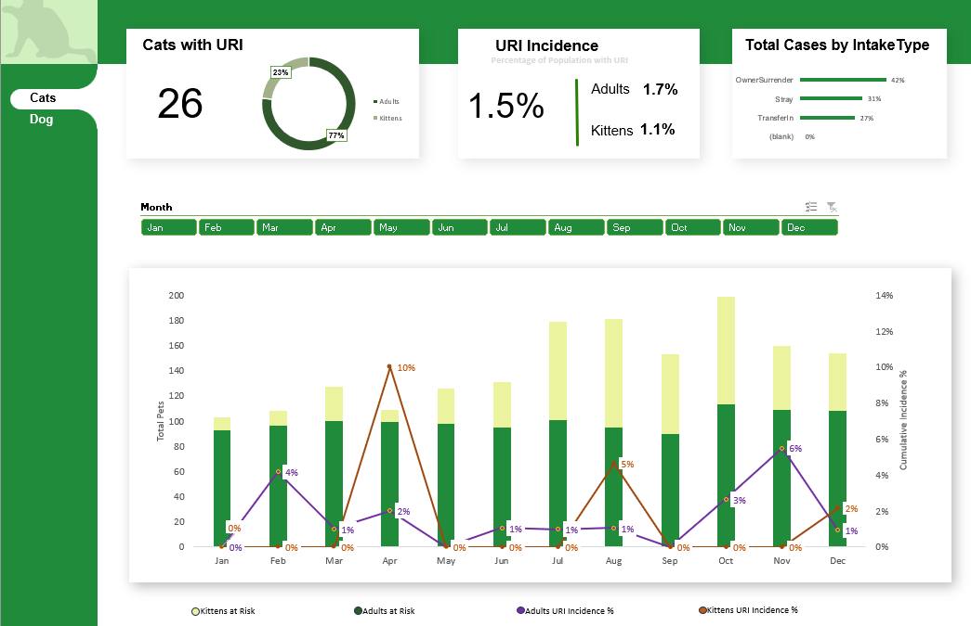

Cumulative Incidence of Feline URI. Incidence (line graph, right axis) is superimposed on population at risk, stratified by age group (stacked bars, left axis).

The summary data at the top shows overall incidence for August (filter above graph). Note that cases are also summarized by intake type, and the graph can toggle between dogs and cats.

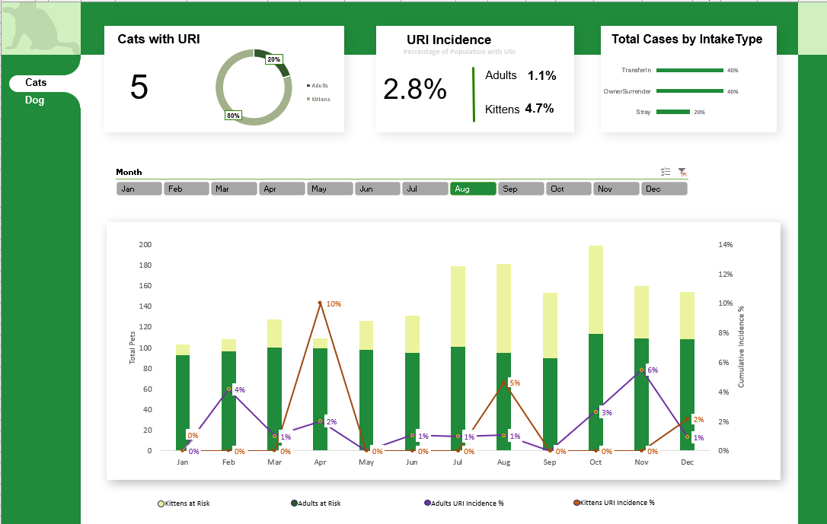

Cumulative Incidence of CIRDC. Incidence (line graph, right axis) is superimposed on population at risk, stratified by age group (stacked bars, left axis).

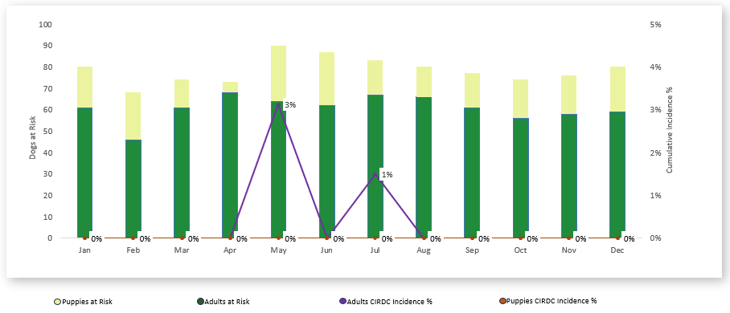

A separate tab provides data tables. The example below is filtered for April and May, and includes both dogs and cats.

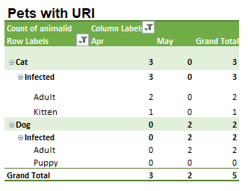
Double-clicking an area of the table (in this case, the 3 infected cats in April), provides details of the individual animals for quick review, if needed (Animal ID cropped out).

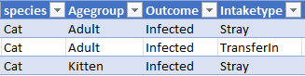

The image below shows a simplified report, presented in the PowerBI Dashboard for high-level “at a glance” monitoring (see next section).

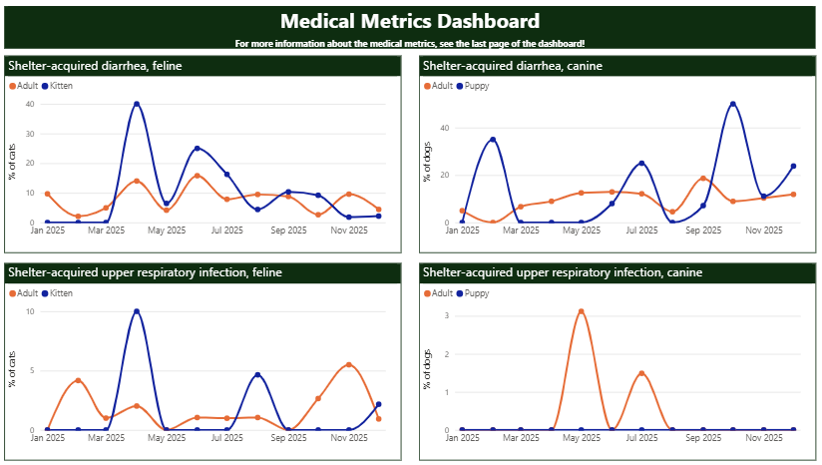

Quality Control

During development of the report, it is important to verify that outputs are valid. Errors may originate in the data itself (e.g. entry errors) or in data processing. Manual reports are compared for errors with the coded report to identify any systemic issues. The quality control is dependent on adequate documentation of the logic of the report generation process.

Technical Implementation

The execution script combines Python user-defined functions and SQL queries to extract the report files from an SQL server accessing the shelter database. By leveraging the capabilities of both Python and SQL, the script facilitates the retrieval and processing of the required data for generating the report files.

The scripts of diarrhea, URI, parvo/panleukopenia and ringworm reports were all created in a similar manner. The only difference was the specific conditions for each case in their corresponding SQL scripts, and the inbuilt lag period to rule out non-shelter-acquired disease.

Source Data Updates
Source data are received from PetPoint on a recurring monthly basis via an automated file transfer process. The reporting process is designed to run after the monthly data file is received.

Current Code Repository
The current technical implementation for this report is available in GitHub:
THS-Metrics/metric-reports.

Report Generation Logic

Necessary information in the database is pulled into a data sheet using SQL server. Data is stored in tables where animal's records can be associated using unique numbers to create a data sheet with all necessary information associated with that animal in a single downloadable excel sheet. Note that it is important to check that these table connections are associating information correctly.

The SQL Query for each script is divided into two parts: Numerator and Denominator.The Numerator query fetches a list of animals with infections.The Denominator dataset combines data on all the pets in the shelter at the start of the month with those that arrived during that same month. Multiple intakes for the same animal are excluded as are animals with the condition of interest onset within the lag period for that condition (to exclude all animals from the denominator that are excluded in the numerator, avoiding inaccurate inflation of the denominator).
Python is used to create a consolidated list of the denominator and a sum is retrieved. It is integral that all animals in the numerator are present in the denominator and that all animals in the denominator have the potential to be in the numerator. For example, one should not include animals in foster in the denominator if they are not counted as cases in the numerator.

The output it written to an Excel file, which serves as the primary output of the data processing step and as the interface between the automated data extraction and the downstream reporting. Within this Excel file, the denominator data are saved to one worksheet, and the numerator data are derived from the consolidated data sheet and saved to a separate worksheet. Storing both components in the same Excel file allows the data to be reviewed, reused, and linked directly to reporting tools.

Data Outputs

Excel-based Reporting File
The report’s Excel-based reporting file has been predesigned with tables and visualizations, with the data source being the output Excel file generated by the python script. generated by the Python script. Whenever the script is executed, the reporting file refreshes automatically, ensuring that it remains updated with changes in the underlying data.

Online Summary Dashboard
An online summary dashboard presents a simplified view of selected metrics derived from the same underlying data. The dashboard uses PowerBI. It is intended for high-level monitoring “at a glance” and does not expose the full underlying dataset available in the Excel-based reporting file. It is available to all staff in our organization.

Automation and Operations

Scheduled Execution
The reporting process is designed to be run automatically on a scheduled basis. Automation consists of executing the Python reporting script at a defined interval in an environment where required dependencies and credentials are available.

For this report, automation is intended to run once per month. Each execution refreshes the processed output files, which in turn update any downstream reporting or summary views that depend on them. Successful execution can be verified by confirming that output files have been updated for the current reporting period.

Automation may be implemented using any scheduling system capable of running a Python script (e.g. task schedulers, cron jobs, or workflow tools), provided the script is executed in a configured Python environment.

Report Change Log
MMDDYY | Change | Initials
11312025 | As of 2025, the reports have been updated to include animals in foster care. Therefore, pre-2025 CI is not directly compared to CI from 2025. | LJ

Every Nose Counts, Scarlett et al 2017

